**Rapid Remote Site Deployment**

Sam Yan

Student ID: 886958

E-mail: [jiangyuey@unimelb.edu.au](mailto:jiangyuey@unimelb.edu.au)

eHealth department of University of Melbourne, Australia

1. CHOSEN SOLUTION
   1. Introduction and summary

The overall solution aims at building a network infrastructure between the camp hospital on the Underbool pheasant farm and the Metro Health data center, ensuring an uplink speed at 28.8 Mbps (57.6% bandwidth of a 4G LTE network) in normal situations and 2.8 Mbps (93.3% bandwidth of a 3G LTE network) on the backup route. It considers the local area network (LAN) structure inside the hospitals by using branch repeaters, bandwidth required by different types of applications, different types of modems, routers with firewalls available and signal amplifiers. (“How fast is 4G? - 4G speeds and UK network performance,” n.d.)

From the hospital to POP1, signal amplifiers are used to ensure quality of service (QoS). The signal amplifiers are put in corresponding positions according to certain rules. Then wired connections are used to transmit data back-and-force between the POP and their corresponding data centers. The overall general infrastructure is shown in fig 1.1-1.

The solution is plausible to the problem stated above. As a second point, it is quick and easy to implement, because the structure from the POP to the two data centers are already built according to Telstra and Optus. Thirdly, by using backup routes and many other backup strategies, the infrastructure is designed to be robust.

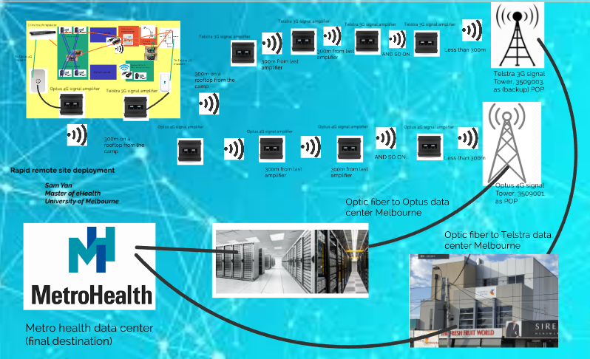

*Fig 1.1-1: Overall infrastructure of the project. The wireless signals between the signal amplifiers means wireless microwaves at certain frequencies (for 4G is 900 MHz and for 3G is 850 MHz).*

* 1. Types of PC/Laptop & Diagnostic devices

Those are the computers and diagnostic devices that should be delivered to the local hospital.

* Types of PC/Laptops

1. 12 computers with Citrix XenDesktop virtual desktop systems (see assumption 1) should be delivered to the place. 4 for the offices of the clinicians, 3 for patient shared ward computers and 2 for nurse stations. And other 3 computers are carried as the “N+1” backup for each of the locations in the camp hospital. (see assumption 3)
2. 5 specific purposes computers for diagnostic purposes, including 2 surgical systems and 3 radiology viewers, put 1 surgical system and 2 radiology viewers to use and remain others as backups. Those computers are expected to have high resolution screens with them for the purposes of viewing diagnostic images following DICOM standards, therefore, Apple Retina displays are suggested as the screens for those computers.
3. 3 general computers for clerical and administrative purposes, with PAS systems on them. 2 of those devices are used by managers to track medical activities and for bills, and 1 for backup. Proposed to use desktop computers are middle level of revolution screens with palm vein recognition systems on it (assumption...), because it is less possible that their work requires immediate access to clinical data and their devices. Less bandwidth is needed.
4. 2 Telstra VOIP phones that are able to conduct video conferences.

* Diagnostic devices:

All the diagnostic devices should be equipped with Ethernet interfaces.

1. One X-Ray machine which has Ethernet interfaces allowing for connecting.
2. One Ultra-sound machine.
3. 2 Pathological stack machines.
4. 10 Patient monitoring systems.
   1. Local area network architecture

Computers located in the nurse station and other image-related diagnostic devices are linked to the two routers directly. (e.g.X-ray machine, Ultrasound machine and ECG) Other devices are each linked to a wired-to-wireless adapter. (e.g.Blood test machine, pathological test machine and PAS). Those wired-to-wireless adapters are able to communicate with 2 routers, which are equipped with firewalls. The virtual private network (VPN) from the camp hospital to Metro Health shall also start at the two routers. Smart phones and other tablet devices in the camps are able to join the wireless network formed by 2 routers of the camp hospital. Packets from them are set to the priorities higher than back up data, but lower than usages of other data.

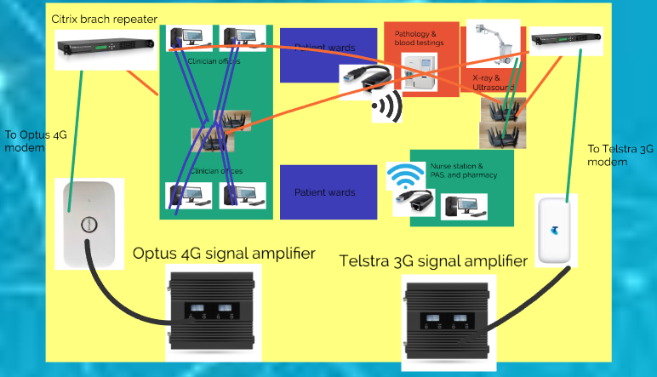

*Fig 1.3-1: Overall infrastructure of the LAN infrastructure inside the camp hospial.*

Different data packets going through the routers are set to different priorities depending on types of data they are sending. Requirements for VoIP and operations on virtual desktops (VoIP packets and packets from virtual desktop computers) are set to higher priorities. IP packets of images, pathological data, blood testing about patients, and other data requires to back up to Metro Health gained on the spot are set to lower priorities on the routes to Metro Health. When the flows of higher priority packets on the routes gets lower or disappears (e.g. lunch time, after-work hours or other possible low-flow periods). Each packet goes through the Citrix branch repeaters (each has 4G RAM and 500G storage) to reduce the use of bandwidth, by caching data as much as data as possible in this priority-based package transfer, and then goes to the routers which links to the first signal amplifier, finishing their roles in the LAN architecture. (“Citrix Branch Repeater - Dual Core E2160 / 4GB RAM / 500GB HDD Network Repeater | eBay,” n.d.)

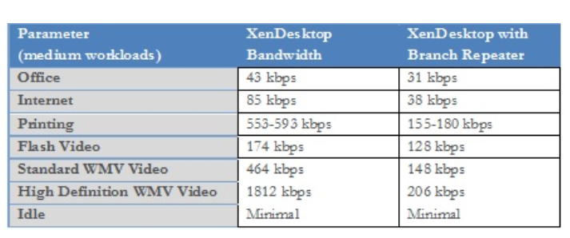

*Fig 1.3–2: Estimated usage of bandwidth of different XenDesktop applications, according to XenDesktop blog.*

* 1. Demountable hospital connection to nearest POP1

According to my search of Oz Towers, 2 wireless base transceiver station (BTS) are found very close to Underbool. One is the 3509001 BTS of Optus, it provides 4G services at many channels. Another is the 3509003 Telstra BTS, it is able to provide 3G services currently. Both of the towers are about 1.5 km away from the Underbool farm land where the proposed hospital locates. The locations and type of services available by corresponding towers are shown as fig 1.5-1 and fig 1.5-2.

The routers sending packages to the VPN back to Metro Health from the camp are linked to 2 branch repeaters (one for 3G signals and one for 4G signals), which are linked to 2 modems (similar, the Optus one for 4G and the Telstra one for 3G) which are linked to 2 signal boosters of the camp hospital. The branch repeaters are used to improve the efficiency of channels of wireless signals, while the signal boosters are used to send wireless signals to 2 corresponding POP BTS. (“Oz Towers, 3509001 - Mallee Highway Underbool VIC 3509.,” n.d.)

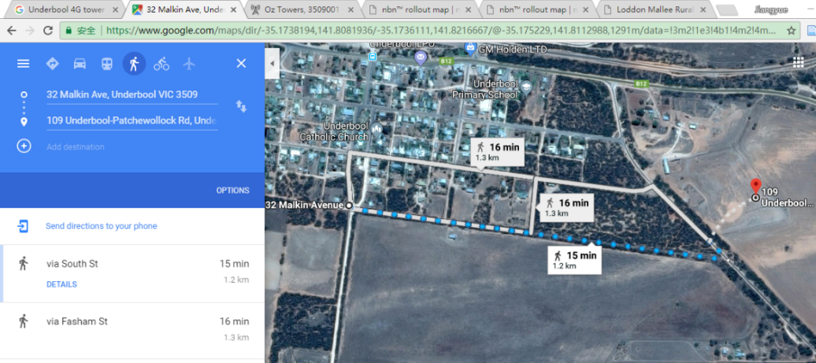

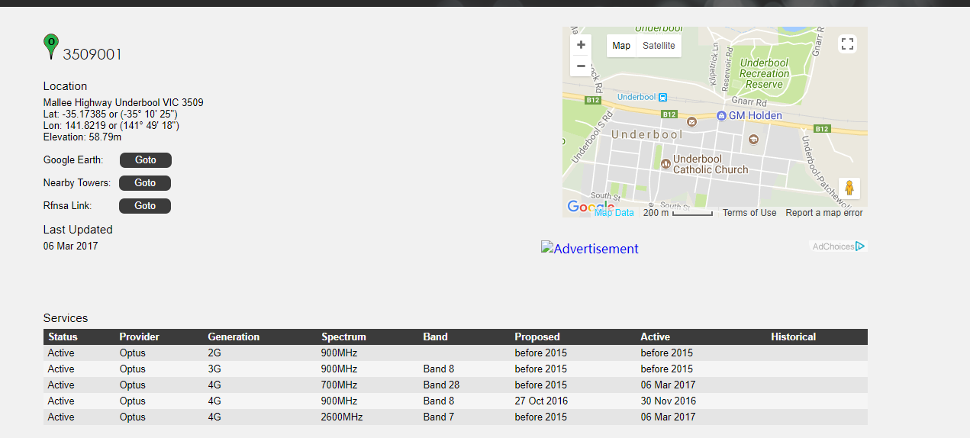

*Figs 1.5 – 1: Location and services available for the Optus base station near Underbool. POP location at: (-35° 10' 25", 141° 49' 18"),which is about 1.2-1.3 km from the camp hospital and the available network type is 4G.*

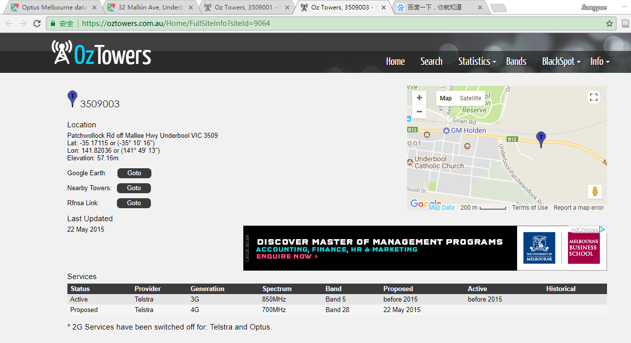

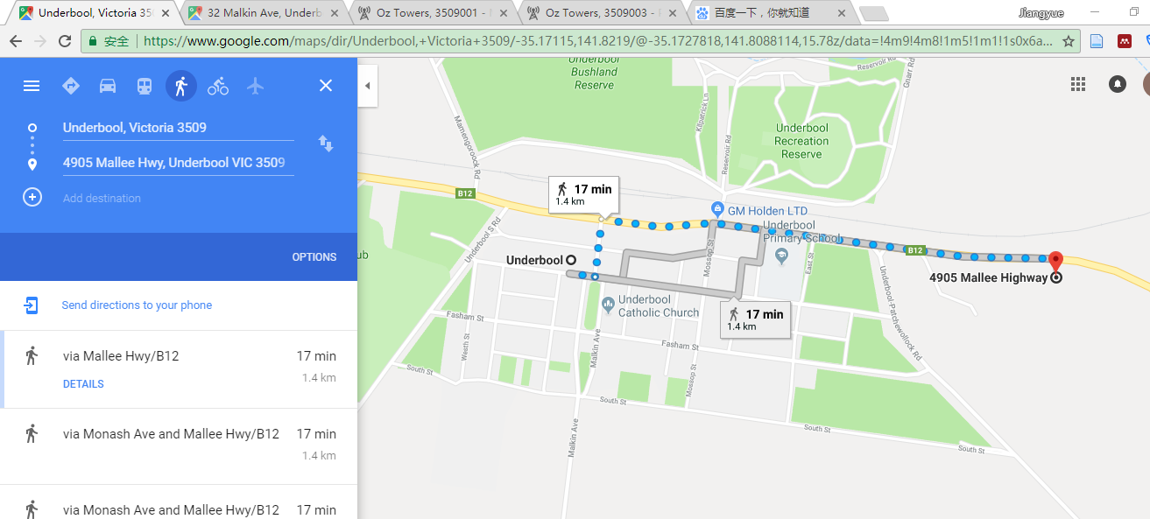

*Figs 1.5 – 2: Location and services available for the Telstra base station near Underbool. POP location at: (-35° 10' 25", 141° 49' 18"),which is about 1.4 – 1.5 km from the camp hospital and the available network type is 4G.*

The signals from the camp hospital is sent from 2 signal boosters (assumption 7), and went through other 2G/3G/4G signal booster points located 300 m to each other, until the BTS, from the camp correspondingly. For each booster place, 2 boosters are used, to send 3G/4G signals to different towers providing corresponding services. (“600 sqm | Tri-Band | All Networks | Signalboostersaustralia,” n.d.)

* 1. Backhaul connection

Two network routes are proposed to link from the POP to the data center of Metro Health.

First route starts from the Optus 4G BTS located 1.3 km away from the camp. (see assumption 6) The whole solution is then relied on Optus network infrastructure. The 4G BTS is linked to a Radio Network Controller (RNC), which links to Serving Gateway General Packets Radio Services (GPRS) Support Nodes (SGSNs) and mobile switching centers (MSCs, for telephony) of Optus, which are linked to Optus data center (through several Gateway GSNs (GGSNs) and Gateway MSCs (GMSC)), according to James and Keith’s book introducing a typical cellular network at p.p.547 - 552), using wired connection. Then the data is transmitted from the Optus data center to Metro Health. (James F. Kurose, 2012)

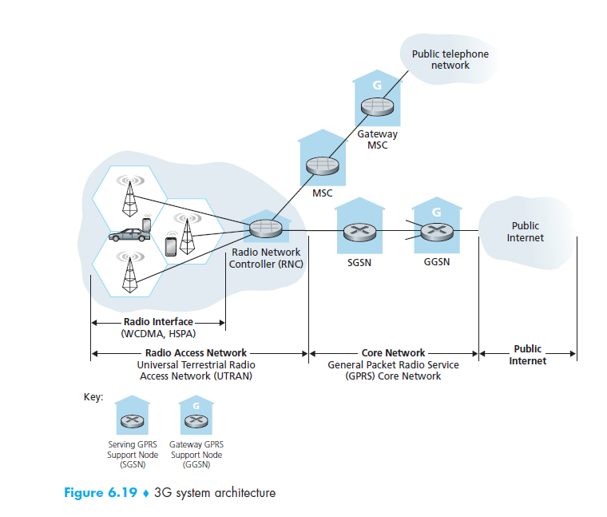

*Fig 1.5-1: A typical infrastructure of 3G cellular network, from James and Keith famous book Computer Networking – A Top-Down approach. According to them, 4G cellular network often uses a similar architecture. For more details, view p.p.547 – 552 of the book.*

The second route is used as a backup route. The route starts from the Telstra 3G Tower located 1.4 km away from the camp. This solution then is relied on Telstra network infrastructure. The 3G Tower links to the nearest RNC, as similar to the previous 4G architecture, which is linked to the Telstra data center, which is Exhibition Street Melbourne "co-location" data center, using wired connection through GSNs and MSCs. Then the data is transmitted from the Telstra data center to Metro Health through wired network.

Link to the POP of the first route is used as the daily use for the camp hospital when it is available and the second route is closed. When drop of connection (e.g. abnormal Round Trip Time, RTT) or congestion is detected, the second route is put into use to reduce the load of route 1 or work as the replacement.

1. SELECTED TOPICS
   1. TECHNICAL SPECIFICATIONS

There are many technical issues under consideration when mentioning technical specifications.

First of all, according to the specification of this scenario, using wireless connections to the nearest POP rather than wired connection is proposed, because according to NBN rollout map, the nearest wired access points to the place of Underbool are all more than 75 km. (“nbnTM rollout map | nbn - Australia’s new broadband access network,” n.d.) Therefore, simply using wired connection to POP in 2 days seems unrealistic and complicated. However, due to the existence of BTS cellular networks for local by 2 cooperation (Optus and Telstra), making use of the towers and passing signals using signal boosters to the tower seems then to be a good choice.

The signal boosters (see assumption 7) each can cover 600 sqms, thus theoretically 3 signal boosters are already enough (1 from the camp, and other 2 each covers 600 m, to cover the distance slightly less than 1.5 km from the camp to the 2 BTSs). However, wireless signals attenuate through the distance, thus in total 5 boosters are used to ensure the strength of signals, which are set to 300 m between each other, therefore ensuring QoS (Quality of Service) of the whole proposed infrastructure.

As for the issue of bandwidth, several aspects are considered. First of all, from the camp hospital to the data center of Metro Health, wireless connections are only used from the camp to the two WAPs, and from several devices sending signals through wired-to-wireless adapter inside the camp hospital. Therefore, the minimum speed of the infrastructure is determined by the upload speed of the two places where wireless connection is proposed, because wired connections (no matter optical fibers or copper fibers) can at least provide speed at 1 Gbps, which is far quicker than 4G LTE. Of the two places using wired signals, a typical TP-LINK wireless adapter can offer a speed at 300 Mbps, therefore, it can be concluded that the speed is determined by the link between the camp and the two WAPs. However, bandwidth is a variable which is determined by different factors (e.g. relative positions of the communicating devices, transport layer protocols, frequency bands and channel qualities) and it various in real environments, therefore, those value provided here are theoretical values. (Akselrod, Becker, Fidler, & Lübben, 2018) (Yuan Zhu, Min Quan Li, & Hong Qing He, 2016)

As another issue of how much bandwidth is required (a minimum need with lowest quality ensured), fig 1.3-2 is used as the source to calculate and the corresponding assumption is then made (assumption 4 and 6), leading to the base conditions of the bandwidth requirements throughout this project.

**Theoretical speed in Mbps found out by different types of wireless networks**

|  |  |  |
| --- | --- | --- |
| Type of wireless network | Max upload speed | Max download speed |
| 5G | 1200 (1.2G) | 7500 (7.5 G) |
| 4G+ (4G LTE Advanced) | 150 | 300 |
| 4G LTE | 50 | 150 |
| 3G+ (3G HSPA+) | 22 | 42 |
| 3G | 3.0 | 14.7 – 16.8 |
| Satellite | 2.5 (Some propose 3.0 – 3.5) | 3.0 |

*Table 2.1-1: Speed in Mbps found of different type of networks, unfortunately, 5G, 4G+ and 3G+ are not available in the proposed infrastructure. The colored rows are available services at the spot proposed by this paper.* (Gozalvez, 2015)

Besides bandwidth of the network, latency of the network has also been considered and is also determined by multiple facts (Rusan & Vasiu, 2015), as mean values displayed below. As can be seen from table 2.1-1 and 2.1-2, although satellite provides similar network bandwidth compared to 3G (some paper even proposed a satellite uplink at 3 – 3.5 Mbps, which is even slightly faster than proposed maximum 3G upload being confirmed), 3G network wins out greatly on the aspect of latency and the service is available at the spot, therefore, this paper propose 3G network as the backup strategy as opposed to satellite network.

Theoretical latencies in ms found out by different types of wireless networks

|  |  |
| --- | --- |
| Type of wireless network | Theoretical latency (mean value) |
| 5G | 4 |
| 4G | 25 |
| 3G | 130 |
| Satellite | 595 |

*Table 2.1-2: Typical latency mentioned in formal paper of different types of network, in ms. From:* (Rusan & Vasiu, 2015)*, whose paper works on estimating latency of 4G network.*

Two firewalls are built in each of the routers in the camp hospital, by changing certain sets of the routers (e.g. Rules of the routing table). The packets are sent to the WAN according to the prioritized rules shown in the following table.

Detailed prioritize strategies on the WAN infrastructure

|  |  |
| --- | --- |
| Type of data packets | Priority |
| To/From virtual desktops (Doctor’s operations require textual data from Metro Health) | 10 |
| VoIP phones, video conferences and getting image data from Metro Health | 9 |
| Tablets / phones in camp hospital | 7 |
| Pharmacy data of the day | 4 |
| PAS data / Management data | 4 |
| Backup HL7 images (X-ray, Ultrasound, blood tests, pathologies) | 4 |

*Table 2.1-3: Proposed prioritize roles for IP packets in the infrastructure from and to the camp hospital*

The proposed links include 2 links (carrier medium, 1 normal 4 G link service and 1 backup 3G link service) shared by packets of different priorities. Therefore, if congestions happen, packets having higher priorities will be sent first, other packets with lower priorities either go to the lower speed back up route (sent through the 3G service) or queue up, if the lower speed link is also congested. Compared to fixed strategies of sending packets (e.g.do the backup after 20:00), this strategy provides more flexibilities and improves utilities of the link. However, the limitation of the cache of the routers and timeout issues of lower-priority packets increases the chances that packets might be dropped and re-transmitted. (James F. Kurose, 2012)

* 1. SECURITY OVERVIEW

Many aspects of security considerations are involved in this scenario.

First of all, user 2 factor authentications (2FA) should be used. The proposed solution therefore for virtual desktop computers, prescribing computers, PACS devices, the X-ray machine, the Ultrasound machine, all blood testing machines and pathological machines are palm vein scanner (see assumption 2) and password. For the first time of the day, qualified users should very their palm veins together as passwords. Those passwords are essentially important, and thus AES (according to Citrix XenDesktop document it is the Advanced Encryption Standard they used) is proposed, to ensure those passwords are transmitted at a level stronger than general financial safety requirements. Here AES is chosen simply because it is supported by the system according to XenDesktop document, however, other methods such as RSA-4096, or SHA-512 are also good encryption alogirthms for this scenario. (Wu & Wu, 2017)

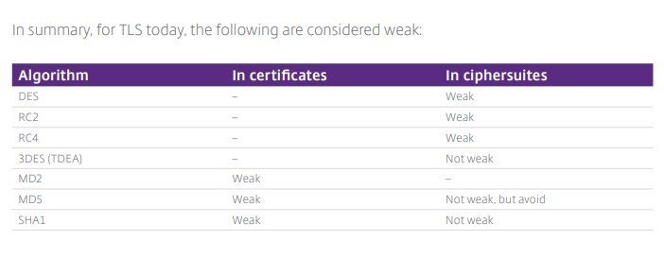

*Table 2.2-1: Comparisons of different encryption algorithms, by Citrix XenDesktop document*

Later on in the day, to avoid wasting time typing passwords, only palm vein scanners are required. Infrared sensors are used to measure the distances between the user and the devices and to manage log off issues. As for licenses, based on assumption 1, the number of licenses should be equal to the number of virtual desktop systems.

Secondly, security issues on the network topology should be considered. As for the LAN architecture, one week point could be from devices generating outputs to the wireless router. To partially solve this issue, Wifi-Protected Access 3 (WPA3) is required for each devices that are trying to link to the 2 routers using wireless connection. Therefore, information can be sent through AES, according to the user document of XenDesktop. As for other devices using wireless connection, the 802.1x authentication mechanism is proposed, to secure those smart phones or tablets wishing to connect to the 2 routers in the LAN structure proposed by this project. (“End-To-End Encryption with XenApp and XenDesktop Security guidance for Citrix Deployments,” n.d.)

For the WAN infrastructure, the VPN shall start from the router of the camp hospital, and ends in the Metro Health data center, which builds an encrypted private link between the camp hospital and the data center, to ensure confidentiality of clinical data. XenDesktop transports socket data using Transport Layer Security TLS protocol (which is a more advanced protocol compared to Secure Sockets Layer, namely the SSL), therefore further securing patients’ data. (“End-To-End Encryption with XenApp and XenDesktop Security guidance for Citrix Deployments,” n.d.)

(Word count = 2087 20 words, without table notations, figure notations and explanatory words that does not add the contents)

Assumptions:

1. Desktop computers should pre-configured, with Virtual Systems. It is assumed all the virtual systems should be able to be used at the same time.
2. Each of the 2 routers equips with a firewall. As for the user 2 factors authentication, passwords + palm vein scanner is used.
3. All the network related devices mentioned in the paper, e.g. wired cables, routers, branch repeaterss, 3G/4G modems and wireless signal amplifiers are of sufficient amount (N + 1) proposed by the amount mentioned in the paper.
4. Suppose for each XenDesktop, 10 office applications, 15 Internet applications, 1 printing task with 180 kbps required, 1 HD WMV video which requires at least 206 kbps is been using. However, when the main route is out of service and the backup route is required, it is supposed that at most we need to ensure at least 2 desktops can operate properly.
5. The Citrix branch repeater is supposed to use the one on this URL: <https://www.ebay.com.au/itm/Citrix-Branch-Repeater-Dual-Core-E2160-4GB-RAM-500GB-HDD-Network-Repeater-/181576300561>
6. 70% of the bandwidth of the Optus 4G Tower / Telstra 3G Tower on band 8 (Optus Tower, with 900 MHz frequency) / 28 (Telstra Tower, with 850 MHz frequency) should be allowed to use under this urgent situation. Based on assumption 4, to ensure the QoS for each of the virtual desktop, about 1.2 Mbps bandwidth is required. For all the desktop to operate properly, therefore around 14.4 Mbps is required, therefore for the provided network, twice of this flow is proposed (28 Mbps) to further ensure QoS. As for the backup route, however, because of the assumption, 2.4 Mbps bandwidth is required and therefore 2.8 Mbps is proposed to remain some flexibility. (Akselrod et al., 2018)
7. Rooftops to place the signal boosters should be available. The signal booster is bought from: <https://www.signalboostersaustralia.com/product/mobile-signal-booster-all-networks-tri-band-600-sqm/?gclid=Cj0KCQjwrLXXBRCXARIsAIttmRMHuiIjSFpGc_524n0QQnayWuO_mhDAimLlvFyT7rAoREANklhCIEAaAr8VEALw_wcB>

BIBILOGRPHY

Akselrod, M., Becker, N., Fidler, M., & Lübben, R. (2018). 4G LTE on the road - What impacts download speeds most? In *IEEE Vehicular Technology Conference* (Vol. 2017–Septe, pp. 1–6). IEEE. https://doi.org/10.1109/VTCFall.2017.8288296

James F. Kurose, K. W. R. (2012). *Computer Networking: a Top-Down Approach*.

Oz Towers, 3509001 - Mallee Highway Underbool VIC 3509. (n.d.). Retrieved May 19, 2018, from https://oztowers.com.au/Home/FullSiteInfo?siteId=9062

Rusan, A., & Vasiu, R. (2015). Assessment of packet latency on the 4G LTE S1-U interface: Impact on end-user throughput. In *2015 23rd International Conference on Software, Telecommunications and Computer Networks (SoftCOM)* (pp. 305–309). IEEE. https://doi.org/10.1109/SOFTCOM.2015.7314072

Wu, Y., & Wu, X. (2017). Implementation of efficient method of RSA key-pair generation algorithm. In *2017 IEEE International Symposium on Consumer Electronics (ISCE)* (pp. 72–73). IEEE. https://doi.org/10.1109/ISCE.2017.8355552

Reasons to list top-5 recommended resources:

1. The paper talks about all the essential factors that impact the download speed of 4G network, which, stated by the author of the paper, “is the de facto communication standard” in the current world. Therefore, having a good understanding of what factors influence the speed of 4G network is important. The paper considered various aspects, such as transport layer protocols, positions of devices and quality of the channels.
2. This is a classic networking “textbook” for everyone who wants to learn basic knowledge about computer networks. It talks about network architecture from application layer down to physical layer, including many details of protocols and services of each layer. Also, the book introduced many up-to-date network applications, standards and services, such as the concepts of cellular networks, 802.1x standards and concepts of IPv6.
3. This website shows the locations of base stations provided by various ISPs among Australia and works as the base for the backhaul architecture of this project. Any IT professionals whose work is related to cellular network services definitely do not want to miss it.
4. This paper talked about the importance to measure the latency of 4G networks, and proposed a novel-new method to measure the latency of 4G network. Those measurements works as essentials to predict and optimize the behaviors of 4G network and therefore the paper worth a read.
5. This paper proposed an algorithm for quickly calculating RSA key-pairs, which is important to the real implementation of this algorithm because with the increment of key size, the calculation time of the key and therefore the encrypted data increases dramatically. And reducing the time of this calculation make it more efficient and safer for the RSA system to work.

app, D. F. D. F. is a L. A. at C. W. a, to 1997, D. V. H. D. B., University, D. has participated in many different deployments taking on many different roles A. graduating from P., WinFrame, D. started out as an I. A. deploying, consultants, M. 1 0 D. soon joined C. C. as one of the first, Largest, S. M. Y. W. on S. of the W., … Virtualization, D. (2010, May 20). How Much Bandwidth Do I Need for My Virtual Desktop. Retrieved May 9, 2018, from <https://www.citrix.com/blogs/2010/05/20/how-much-bandwidth-do-i-need-for-my-virtual-desktop/>

Branch Repeater specification sheet. (2014), 2.

Chaitra, S., & Sharma, R. (2017). Integration of Software Router with Wi-Fi for Enhanced Security. In *2017 IEEE 7th International Advance Computing Conference (IACC)* (pp. 33–36). <https://doi.org/10.1109/IACC.2017.0022>

Citrix Branch Repeater - Dual Core E2160 / 4GB RAM / 500GB HDD Network Repeater. (n.d.). Retrieved May 19, 2018, from <https://www.ebay.com.au/itm/Citrix-Branch-Repeater-Dual-Core-E2160-4GB-RAM-500GB-HDD-Network-Repeater-/181576300561>

end-to-end-encryption-with-xenapp-and-xendesktop.pdf. (n.d.). Retrieved from <https://www.citrix.com/content/dam/citrix/en_us/documents/white-paper/end-to-end-encryption-with-xenapp-and-xendesktop.pdf>

Enterprise Mobility 4.1 Design Guide - Cisco Unified Wireless Network Architecture—Base Security Features [Design Zone for Mobility]. (n.d.). Retrieved May 17, 2018, from <https://www.cisco.com/c/en/us/td/docs/solutions/Enterprise/Mobility/emob41dg/emob41dg-wrapper/ch4_Secu.html>

Fu, Y., Gu, R., & Ji, Y. (2017). Experimental Demonstration of #x201C;PON #x002B; Embedded-Hardware-Switch #x201D; for Low-Latency Communication in Dual-Stage 5G Fronthaul Network Architecture. In *2017 European Conference on Optical Communication (ECOC)* (pp. 1–3). <https://doi.org/10.1109/ECOC.2017.8346020>

Gozalvez, J. (2015). Samsung Electronics Sets 5G Speed Record at 7.5 Gb/s [Mobile Radio]. *IEEE Vehicular Technology Magazine*, *10*(1), 12–16. <https://doi.org/10.1109/MVT.2015.2390931>

How fast is 4G? - 4G speeds and UK network performance. (n.d.). Retrieved May 14, 2018, from <https://www.4g.co.uk/how-fast-is-4g/>

Khan, F. (2005). A time-orthogonal CDMA high-speed uplink data transmission scheme for 3G and beyond. *IEEE Communications Magazine*, *43*(2), 88–94. <https://doi.org/10.1109/MCOM.2005.1391506>

Levy, G., Blumberg, N., Kreiss, Y., Ash, N., & Merin, O. (2010). Application of information technology within a field hospital deployment following the January 2010 Haiti earthquake disaster. *Journal of the American Medical Informatics Association : JAMIA*, *17*(6), 626–630. <https://doi.org/10.1136/jamia.2010.004937>

ltd, nbn co. (n.d.). nbnTM rollout map | nbn - Australia’s new broadband access network. Retrieved May 1, 2018, from [https://www.nbnco.com.au/learn-about-the-nbn/rollout-map.html#](https://www.nbnco.com.au/learn-about-the-nbn/rollout-map.html)

Pavarangkoon, P., Murata, K. T., Okada, M., Yamamoto, K., Nagaya, Y., Mizuhara, T., … Kimura, E. (2016). Bandwidth utilization enhancement using high-performance and flexible protocol for IN℡SAT satellite network. In *2016 IEEE 7th Annual Information Technology, Electronics and Mobile Communication Conference (IEMCON)* (pp. 1–7). <https://doi.org/10.1109/IEMCON.2016.7746292>

Saravanan, S. (2016). Telemedicine using computer communication network and make 3G and 4G USB internet modem antenna and mobile satellite antenna to improve internet speed for downloading and uploading patient details. In *2016 International Conference on Computer Communication and Informatics (ICCCI)* (pp. 1–5). <https://doi.org/10.1109/ICCCI.2016.7479926>

Sidik, A., Fathany, M. Y., & Alam, B. R. (2015). Design of broadband Low Noise Amplifier (LNA) 4G LTE TDD 2.3 GHz for modem application. In *2015 International Symposium on Intelligent Signal Processing and Communication Systems (ISPACS)* (pp. 488–492). <https://doi.org/10.1109/ISPACS.2015.7432821>

TP-LINK 300Mbps Wireless N Mini USB Adaptor. (n.d.). Retrieved May 14, 2018, from <https://www.officeworks.com.au/shop/officeworks/p/tp-link-300mbps-wireless-n-mini-usb-adaptor-tptlwn823n>

Widyantara, I. M. O., Satwika, I. K. S., & Pramaita, N. (2016). An approach for selecting optimum number of base stations using harmony search. In *2016 International Conference on Smart Green Technology in Electrical and Information Systems (ICSGTEIS)* (pp. 69–73). <https://doi.org/10.1109/ICSGTEIS.2016.7885769>

Zhu, Y., Li, M. Q., & He, H. Q. (2016). A compact dual-band monopole antenna for 4G LTE and WIFI utilizations. In *2016 IEEE MTT-S International Microwave Workshop Series on Advanced Materials and Processes for RF and THz Applications (IMWS-AMP)* (pp. 1–4). <https://doi.org/10.1109/IMWS-AMP.2016.7588432>